Project Design Phase-II
Technology Stack (Architecture & Stack)

Date | 23 June 2026
Team ID
Project Name | An employee requests installation of licensed software through the Service Catalog
Maximum Marks | 4 Marks

Technical Architecture:
The Software Installation Request Automation system is built on the ServiceNow Platform to automate the complete lifecycle of software installation requests. Employees submit requests through the Service Portal, where catalog variables capture software details and business justification. The request is processed using Service Catalog and Workflow Editor, which automatically manages approvals, generates catalog tasks, sends notifications, and tracks fulfilment until completion.
The solution follows a layered architecture consisting of a user interface, application logic, ServiceNow database, workflow automation, notification services, and update set deployment. This architecture reduces manual effort, improves request visibility, and ensures consistent request processing.
Software Installation Request Automation
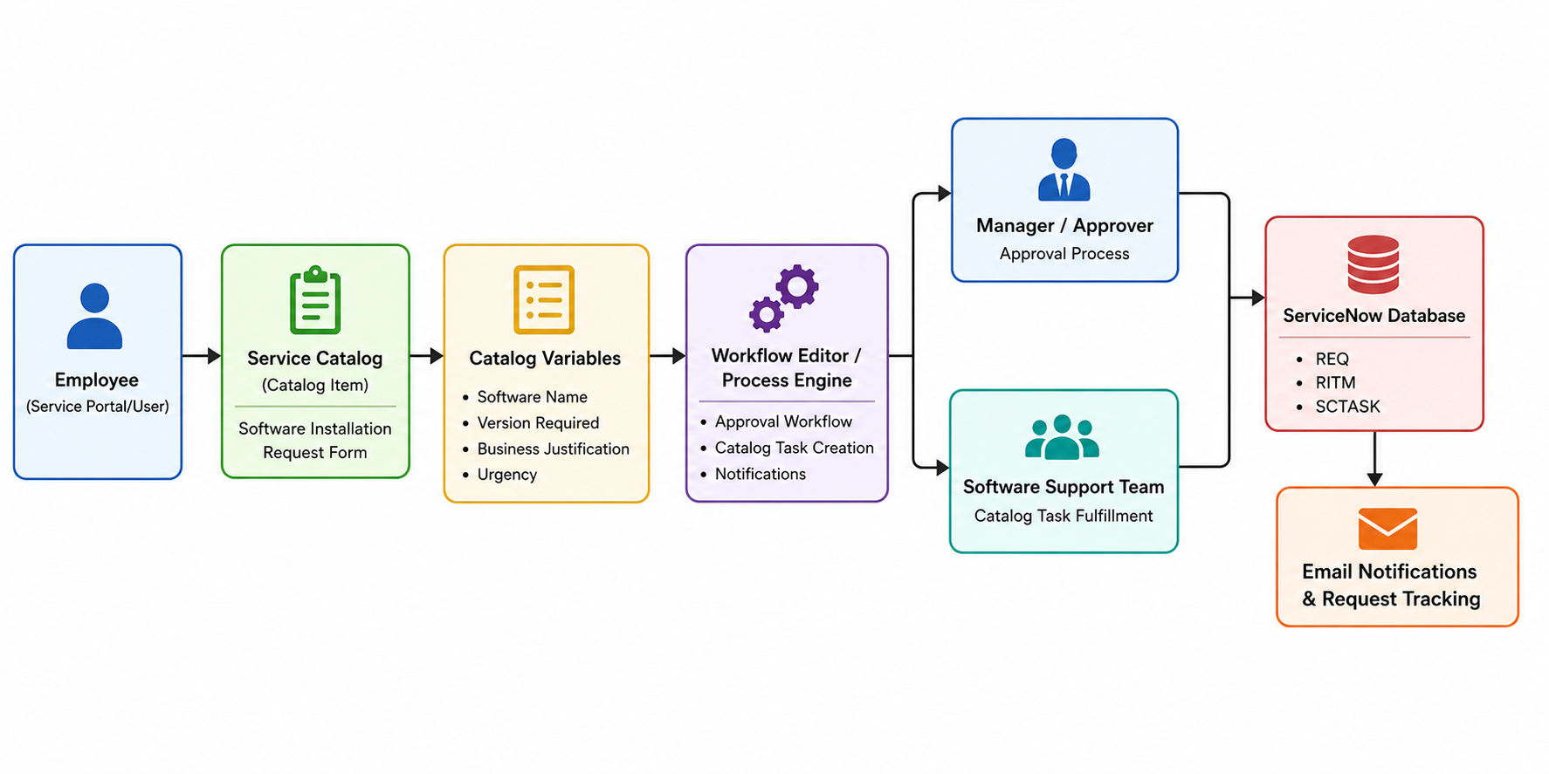

Table-1 : Components & Technologies:

S.No | Component | Description | Technology
1 | User Interface | Employees submit software requests through the Service Portal and Service Catalog. | Service Portal, Service Catalog
2 | Application Logic-1 | Processes catalog submissions and validate request details. | ServiceNow Service Catalog
3 | Application Logic-2 | Automates approvals, task creation, and request lifecycle. | ServiceNow Workflow Editor
4 | Application Logic-3 | Sends notifications and updates request status automatically. | Notifications, Email Engine
5 | Database | Stores requests, requested items, catalog tasks, approvals, and variables. | ServiceNow Tables (sc_request, sc_req_item, sc_task)
6 | Cloud Database | Cloud-hosted ServiceNow platform database. | ServiceNow Cloud Platform
7 | File Storage | Stores request attachments uploaded by users. | ServiceNow Attachment Service
8 | External API-1 | Email notifications for approvals and task updates. | ServiceNow Email Notification
9 | External API-2 | Not used in the current implementation. | N/A
10 | Machine Learning Model | Not implemented in this project. | N/A
11 | Infrastructure (Server/Cloud) | Application hosted on ServiceNow Personal Developer Instance (PDI). | ServiceNow Cloud (PDI)
Table-2: Application Characteristics:

S.No | Characteristics | Description | Technology
1 | Open-Source Frameworks | Uses ServiceNow's built-in platform capabilities with standard web technologies. | HTML, CSS, JavaScript, ServiceNow Platform
2 | Security Implementations | Role-based access control, workflow approvals, authentication, and data validation. | ACLs, User Roles, UI Policies, Business Rules
3 | Scalable Architecture | Multi-tier cloud architecture capable of supporting additional catalog items and workflows. | ServiceNow Cloud Platform
4 | Availability | High availability through the ServiceNow cloud platform with continuous uptime. | ServiceNow SaaS Infrastructure
5 | Performance | Optimized using ServiceNow workflow automation, indexed tables, and efficient request processing. | Workflow Engine, ServiceNow Database

References:
https://developer.servicenow.com/
https://docs.servicenow.com/
https://www.servicenow.com/community/
https://c4model.com/
https://aws.amazon.com/architecture/
https://medium.com/the-internal-startup/how-to-draw-useful-technical-architecture-diagrams-2d20c9fda90d

